# NIRVANA - 2023

## CERTIFICATE OF ACHIEVEMENT

This Certificate is awarded to Crescendo team from VNRVJIET for participating in Battle of Bands

conducted by Symphony Music Club of MGIT on 29th

April,2023 and won first prize.

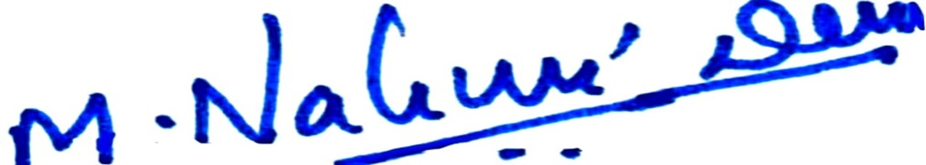

Dr.M Nalini Devi

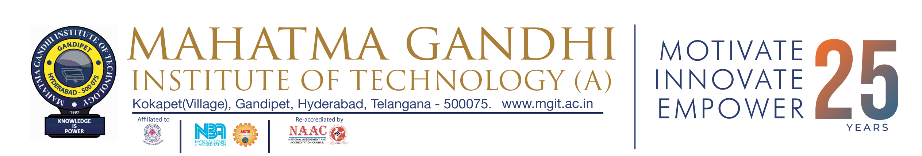

Music Club-Coordinator

Dr.G Chandra Mohan Reddy

Principal